XVI ASPAC International Scientific Conference and International Museological School in Barnaul-Zmeinogorsk / Russia
April 16-20 in Barnaul and Zmeinogorsk
ASPAC is the organizer of the XVI International Symposium "Preservation, Study and Restoration of the Cultural Heritage of Altai Territory", which was held April 16-20 in Barnaul and Zmeinogorsk. This International Symposium ASPAC in Barnaul brought together more than 400 specialists of educational institutions in 3 cities and 16 districts of the Altai Region, scientists of higher educational institutions of Germany, Kazakhstan, Mongolia, Russia (Altai, Novosibirsk, Kemerovo Region), Taiwan.
XVI ASPAC International Scientific Conference:
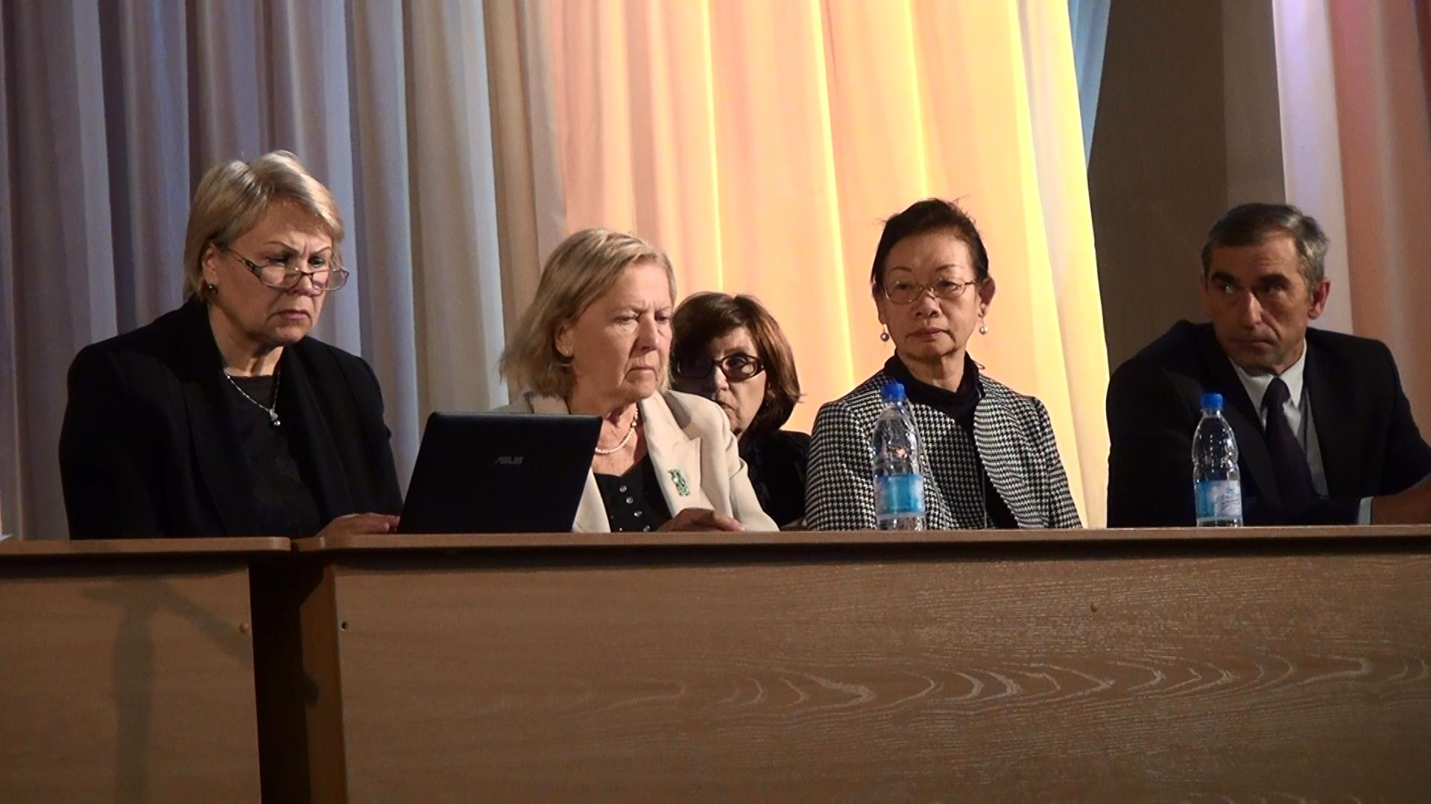
The main lecturs of the conference were:
- Professor H. K. Vieregg “The development of Museum education system in Germany”
- Professor Chen Kuo-Ning – “The Heritage Education Programs in Museums of Taiwan "
- Professor O. Truevtseva – “Project “The Red book of the cultural heritage of the Altai territory, which is under threat of extinction”
- Dovadola C. "Intangible heritage of Mongolia: the tradition of making national boot"
- Azamat Aysegul “The Museum is in the child's upbringing in Mongolia”
- Nayzabekov Almakan “Research project "the Germans in the history of Kyrgyzstan"
- Khash - Erdene Sambalhundev – “The Contribution of the Mongolian nomadic Empire in world civilization”
and more than 60 papers were presented in 5 sections.

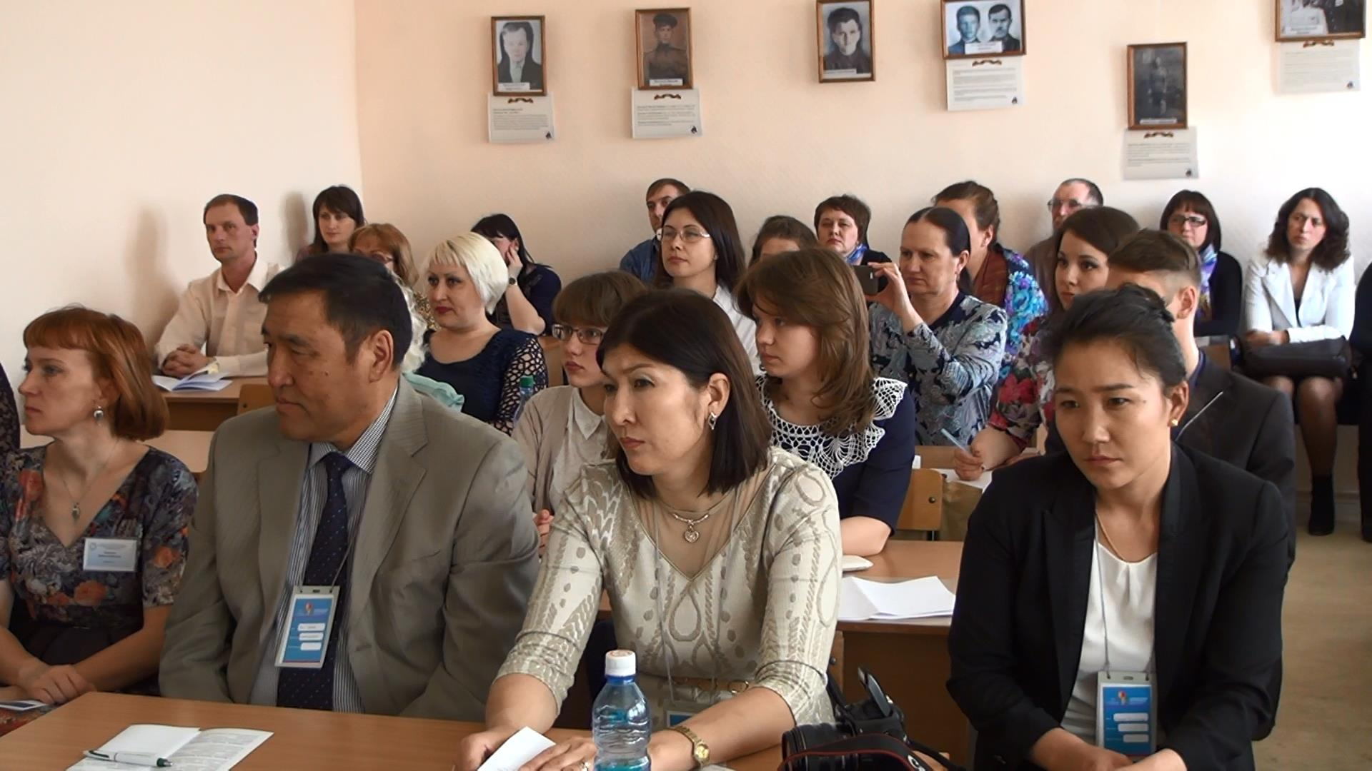

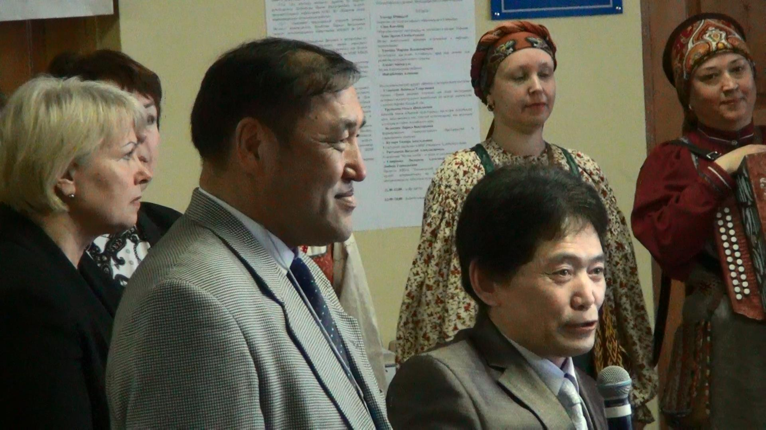
Opening speech of Rector of Margad University Tsogtbadrah Erdenechuluun and vice-rector H. Sambalhundev from Mongolia

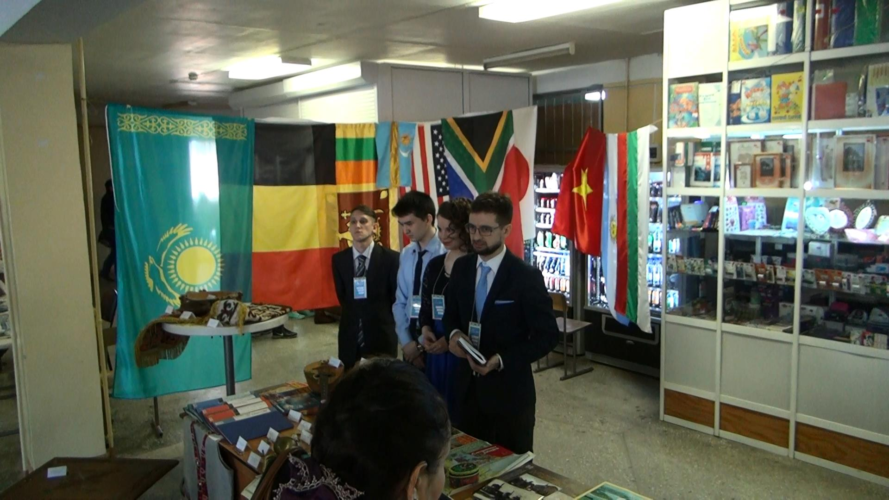
The Exhibition of The House Of Geography, Kazakhstan
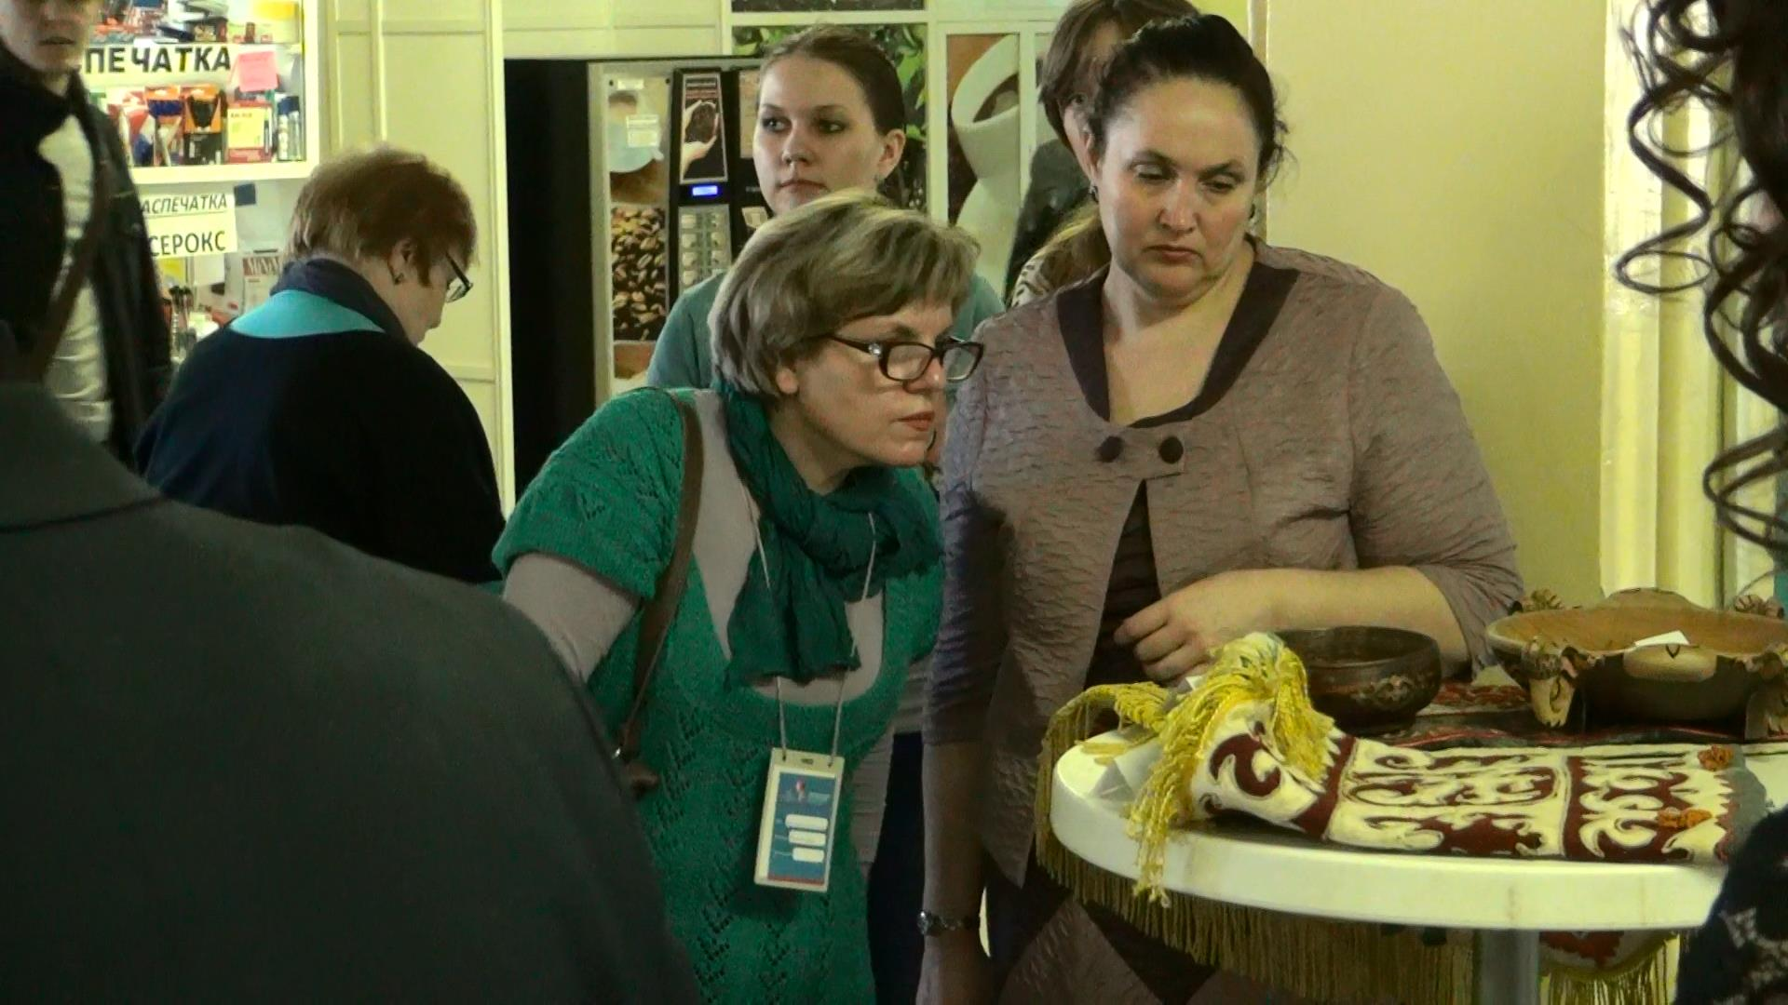

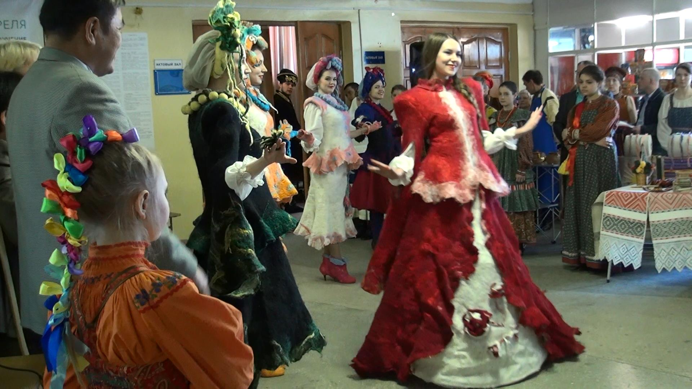

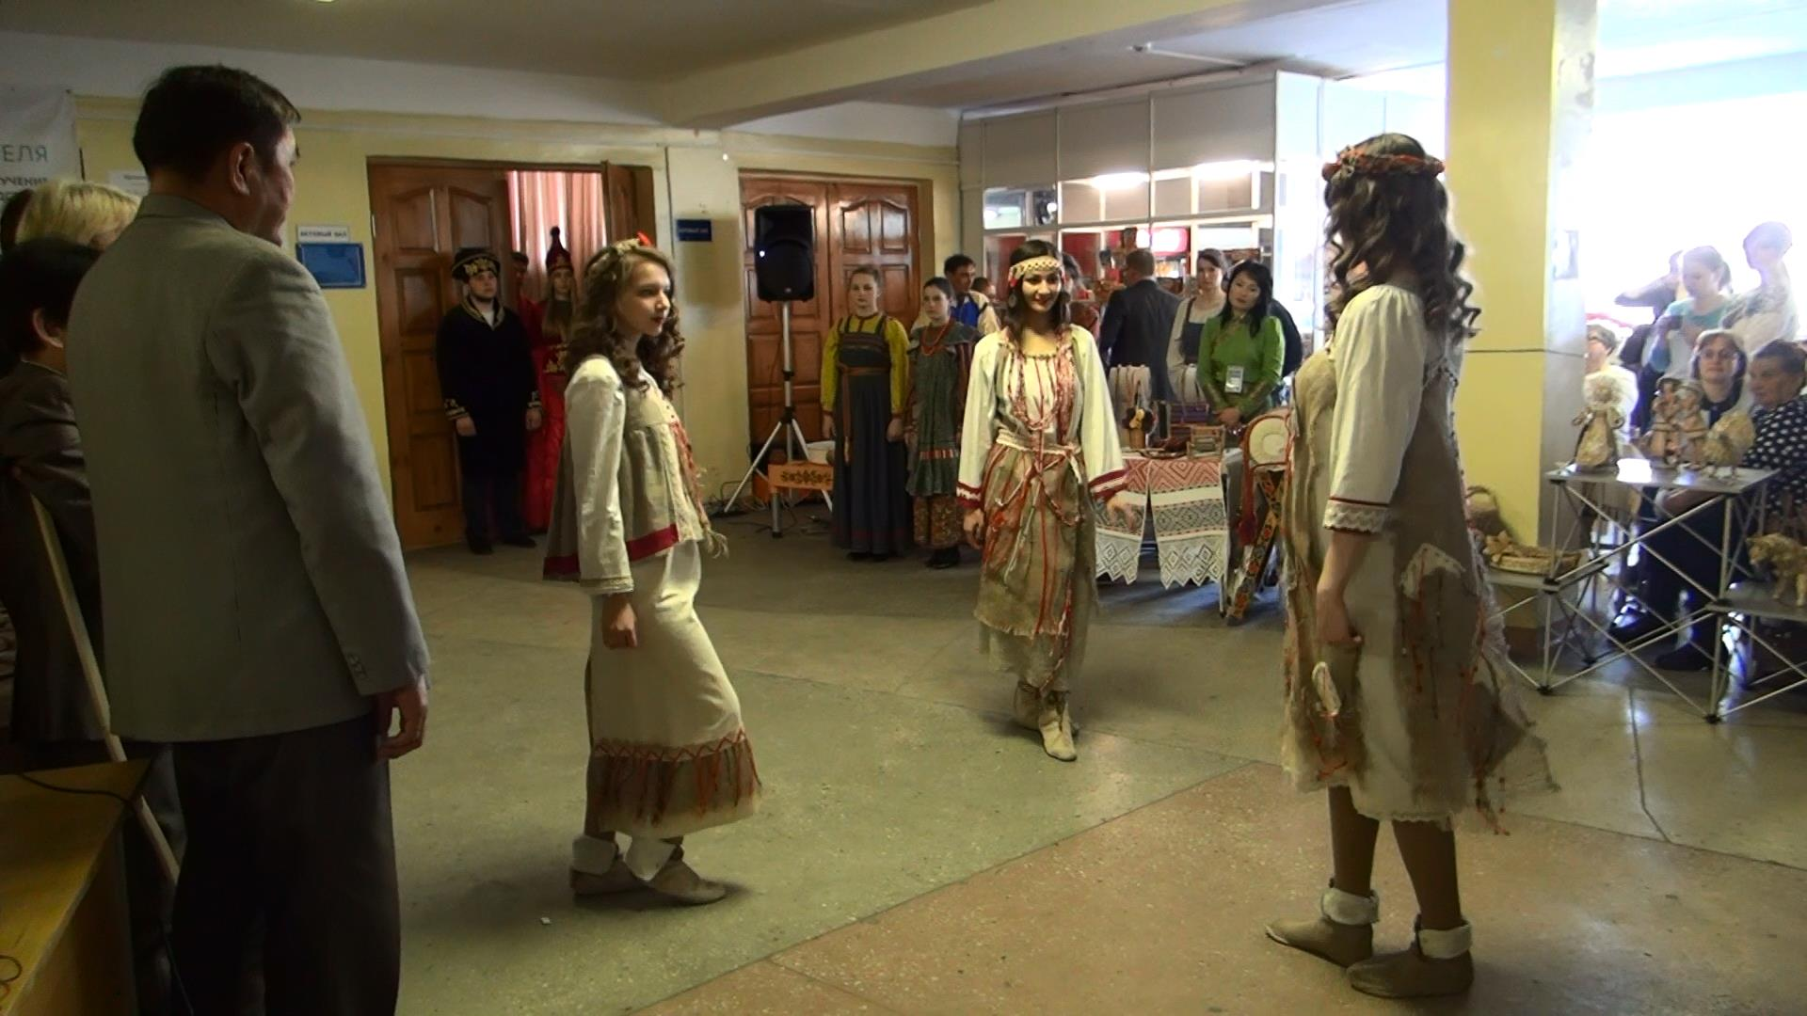
Presentation of the ethnographic collections of the national clothes
Master-classes of Russian culturel haritage:

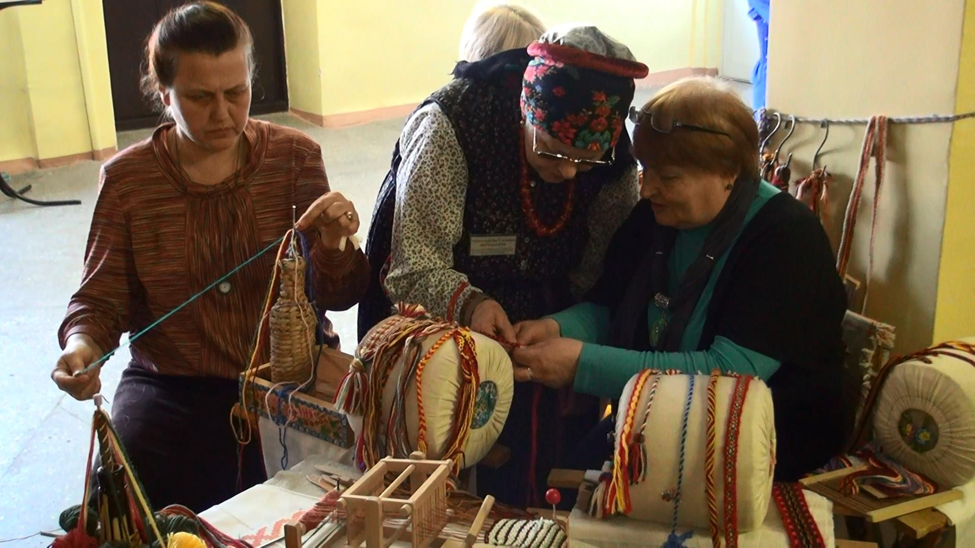

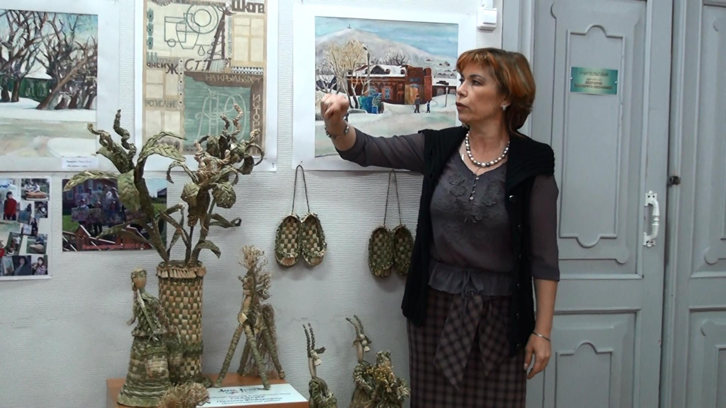

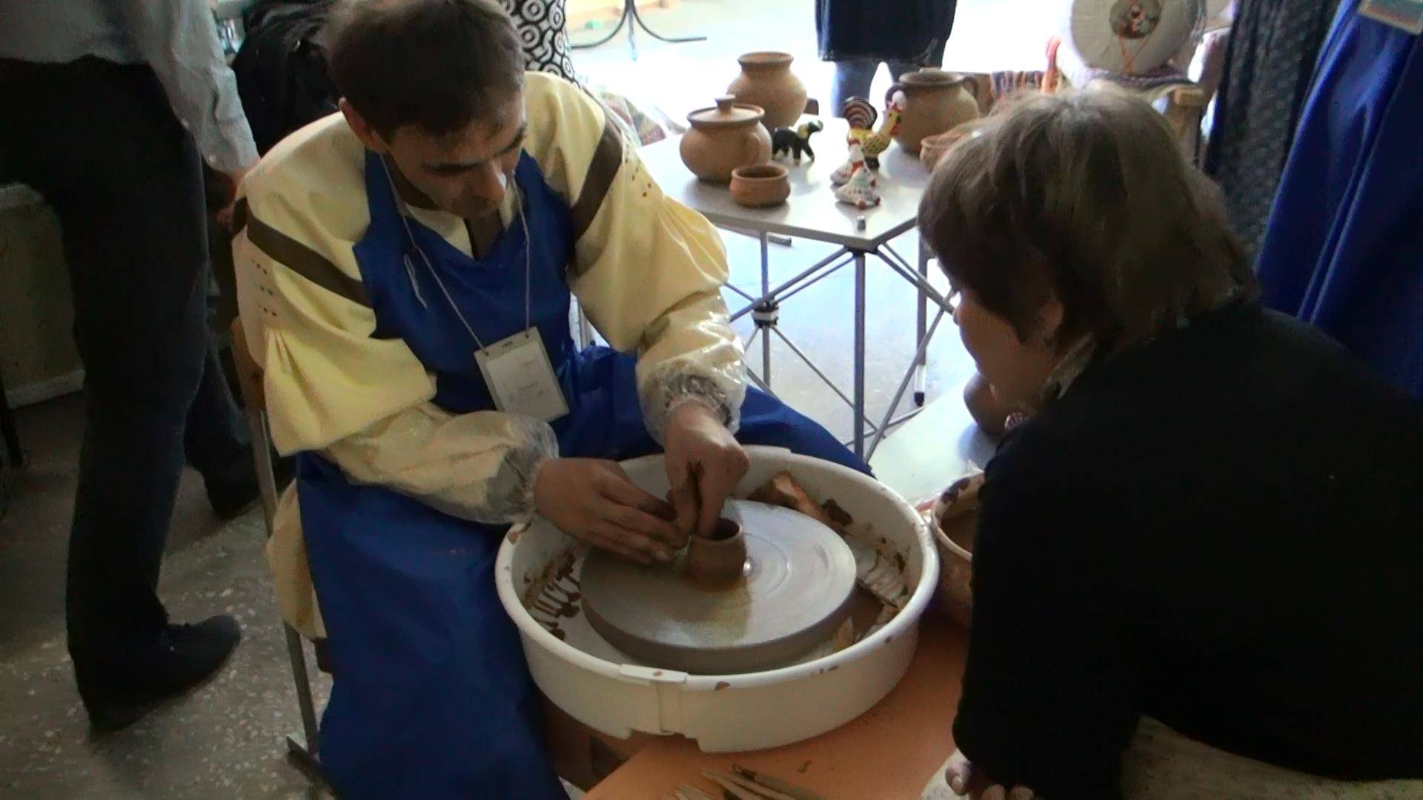
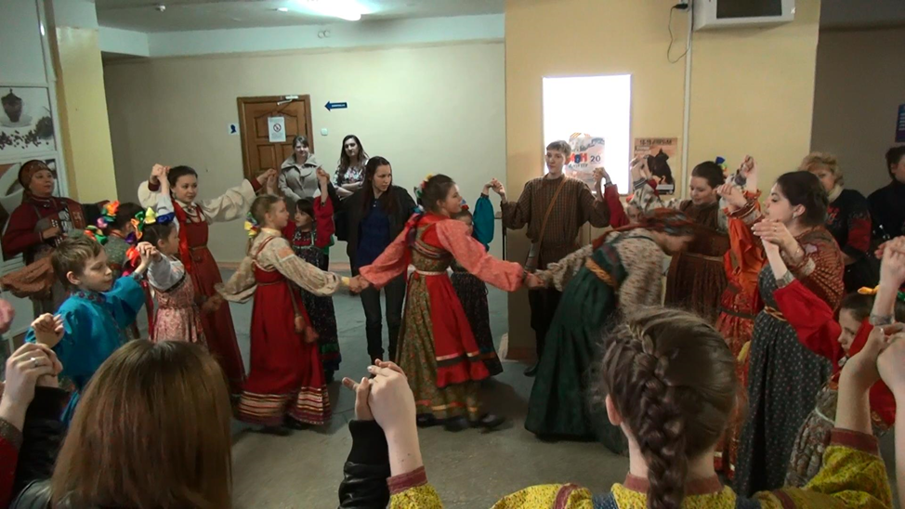
Vice presidents of ASPAC: Professor H. K. Vieregg, Professor at the University of Philosophy in Munich/Germany, visited the Altai territory at the 16th-time. Professor Chen Kuo-ning, Director of the Museum of World Religions in Taipei/Taiwan Professor H. Sambulhundev Erdene/Mongolia and Professor Shelegina O. N. – researcher, Institute of History Siberian Academy of Science again met with the leadership of the Altai State Pedagogical University and gave lectures to the teachers and students of the Altai Region. They discussed also the main problems for prepare ASPAC Annual Meeting in Taiwan at the October 2015.
Altai State Pedagogical University was chosen as the main area for the symposium, because scientists of the University, headed by the project manager, O.N. Truevtseva Doctor of Historical Sciences and professor, , are the core of the creative team, which also includes experts from organization "Heritage", historians from Barnaul, Zmeinogorsk, and Pavlovsk.
Issues, the project deals with, caused a wide resonance not only among local historians of Altai Krai, but also representatives of the international museological community. Over 20 experts from 11 countries took part in the collection of research papers prepared for the conference.
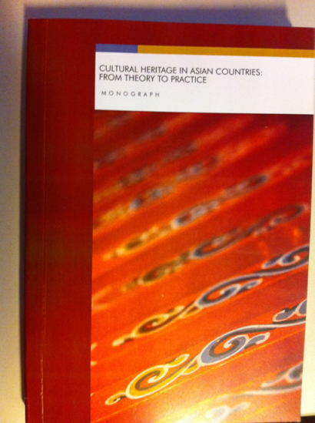
In the preface to the monograph "CULTURAL HERITAGE IN ASIAN COUNTRIES: FROM THEORY TO PRACTICE", François Mairesse, President of the International Committee for Museology (ICOFOM in ICOM/UNESCO) emphasized on the significance of the recently increased potential of Asia-Pacific museological community, headed by O.N. Truevtseva.

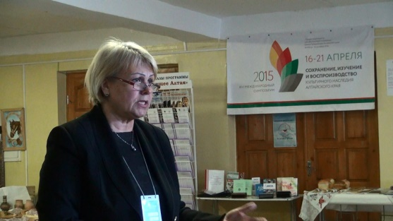
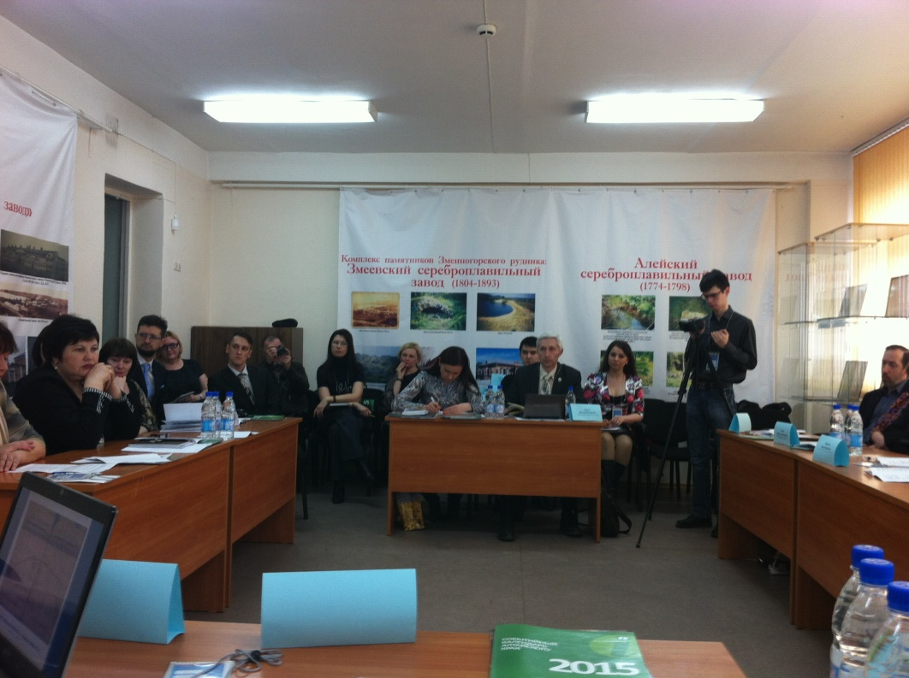
The opening of the symposium was preceded by a Round-table discussion, during which the project "Red Book" was discussed in detail. The participants noted the great work on the collection of comprehensive information and the creation of a database of endangered cultural heritage of Mining production of Altai, including scientific description, photographic images, compiling bibliographies for each object, etc. The first object of the electronic version of the book became Barnaul, Pavlovsk, Loktevsky, Aleysk, Zmeinogorsk silver-plants.
At the symposium, much attention was paid to attracting children and youth to the preservation of cultural heritage. Stands, exhibitions, workshops revealing the experience of teachers of educational institutions of the region, were prepared especially for schoolteachers. About 400 participants representing educational institutions of 3 cities and 16 districts of the Altai Territory, with great interest listened to speeches by Professor H. Vieregg from Germany, director of the Museum of World Religions Chen Kuo-Ning from Taiwan, Rector of Margad University Tsogtbadrah Erdenechuluun and vice-rector H. Sambalhundev from Mongolia, young professionals from "Pavlodar House of Geography."
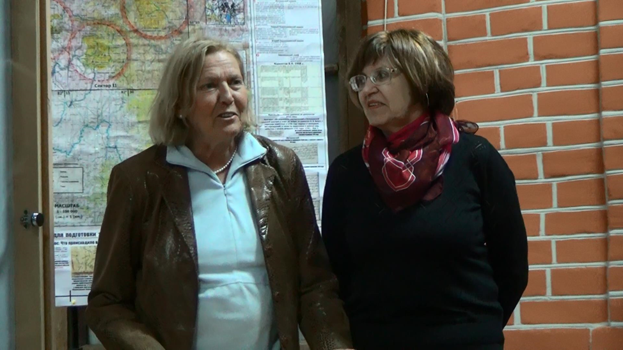
Professor H. Vieregg /Germany
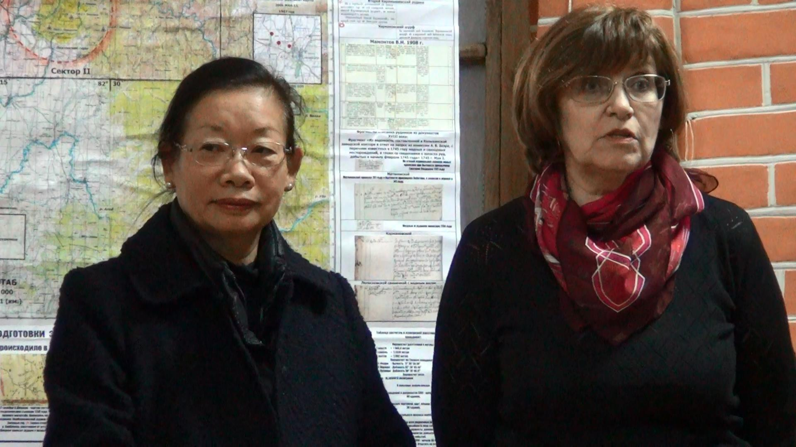

Professor Chen Kuo-Ning, director of the Museum of World Religions from Taiwan together with the interpreter Nadeghda Shirokova, vice director of Lingwistic Institute of Altai State pedagogical University

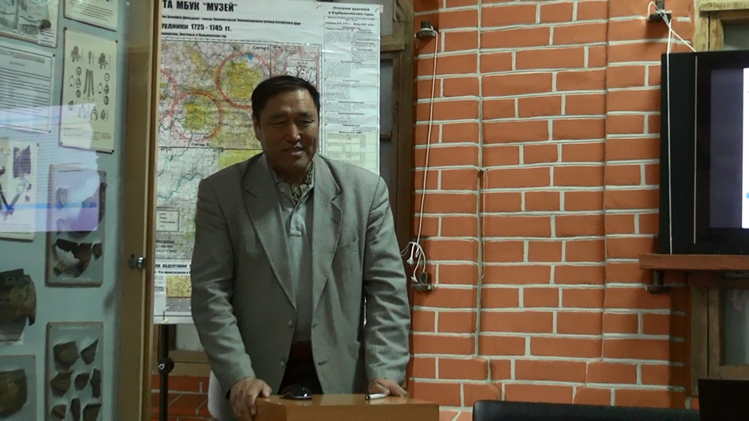

Vice-Rector of Margad University, H. Sambalhundev from Mongolia
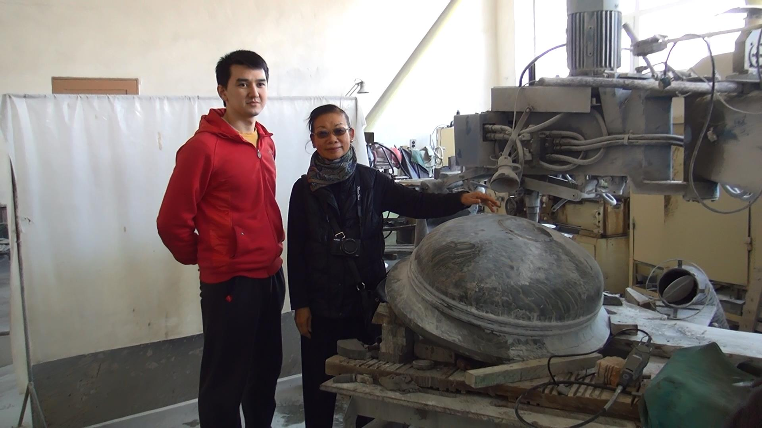
The participants of the symposium had the opportunity to visit the museums in Zmeinogorsk, Kuryi, Kolyvan. Warm applause went to the creative team of School of Arts "Tradition" from village Vlasikha, who acquainted visitors with the best examples of traditional culture of Altai. The participants showed genuine interest to unique exhibition defile of national costumes "Ethno-cultural heritage of the peoples of Altai" presented by creative teams of Altai State House of Folk Arts "Russian Folk Union"; Faculty of Arts, Altai State University, teachers of "Regional Centre for Information and technical work".
Representatives of the Regional Centre for Information and Technical Work of the Office of Education and Youth actively participated in the symposium as well.
The guests’ attention was attracted by methodical exposition of the regional program for talented students and young people and "The Future of Altai", prepared by the scientific and methodological department, and an exhibition of 115 works on children's arts and crafts and technical creativity.

